Step by Step Screenshots:
3. Probe specific products at bespoke settings
1. Configure the PXmonitor to your business
2. View the status of all tasks in one place

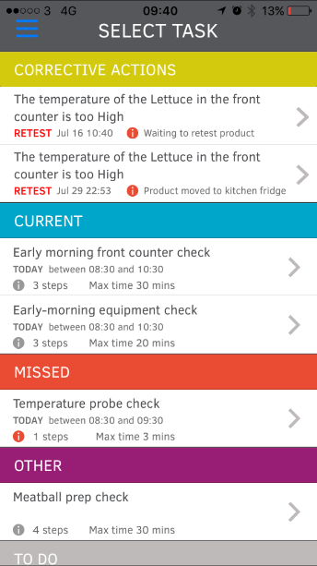
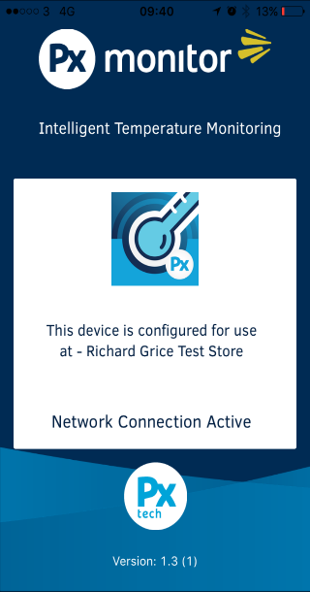
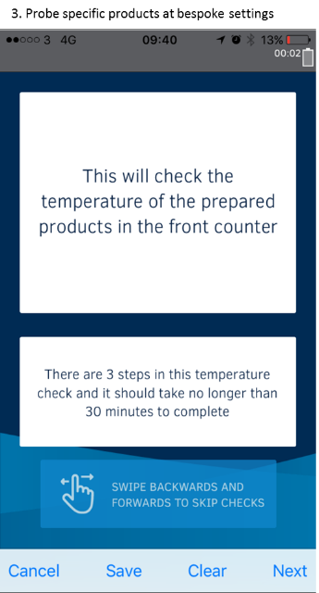

6. Easily authorise all PXmonitor usage
4. Follow precise operating instructions
5. Receive instant, informative feedback
